SMART ALCOHOL INTOXICATION DETECTION AND PREVENTION SYSTEM USING AI
Block Diagrams (all)
Department of Computer Science and Engineering, TKR College of Engineering and Technology (Autonomous)
Batch A6 (CSE-A) · Academic year [ACADEMIC YEAR]
Table 1: Project team
S.No. | Student name | Roll number
1 | B PRANITHA | 23K91A0522
2 | BANTU KAVYA | 23K91A0531
3 | DASARI VIVEKA SARVESHWARI | 23K91A0560
4 | BEKKAM VAMSHI | 23K91A0534

Project guide: N. PADMAVATHI
Chapter and section numbers quoted in the text (for example Section 6.6 or Chapter 8) refer to the full project report, 17.Final Document. Figures and tables in this document are numbered from 1.

1. INDEX OF DIAGRAMS
Every diagram is generated from the real design by scripts/make_diagrams.py (matplotlib, 150 dpi) and mirrors the code in core.py, vision.py, storage.py, research.py, app.py and backend/.
Table 2: Diagrams in this document
No. | Diagram | Image file
1 | System architecture | docs/diagrams/01_system_architecture.png
2 | High-level workflow | docs/diagrams/02_high_level_workflow.png
3 | Data flow diagram, level 0 | docs/diagrams/03_dfd_level0.png
4 | Data flow diagram, level 1 | docs/diagrams/04_dfd_level1.png
5 | Data flow diagram, level 2 | docs/diagrams/05_dfd_level2.png
6 | UML class diagram | docs/diagrams/06_uml_class_diagram.png
7 | Sequence diagram | docs/diagrams/07_sequence_diagram.png
8 | Use-case diagram | docs/diagrams/08_use_case_diagram.png
9 | Entity-relationship diagram | docs/diagrams/09_er_diagram.png
10 | Flowchart of the core algorithm | docs/diagrams/10_core_algorithm_flowchart.png

2. DIAGRAMS

System architecture
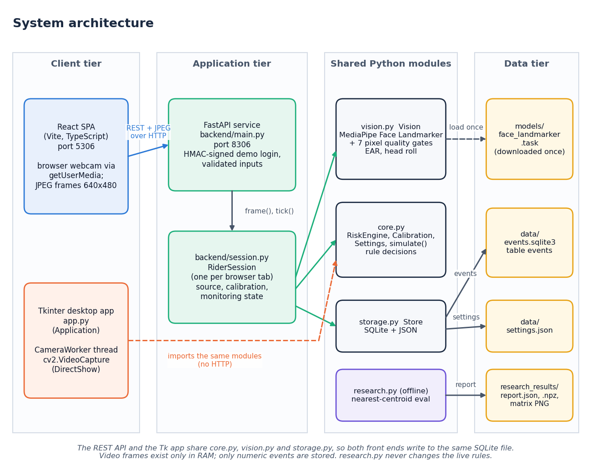
Figure 1: System architecture of the Smart Rider impairment warning system
The architecture has four columns. The client tier holds the two ways to reach the system: the React single-page application (Vite and TypeScript, port 5306), which opens the rider's webcam with the browser's getUserMedia and sends 640 x 480 JPEG frames, and the original Tkinter desktop application app.py, which reads the webcam itself through a CameraWorker thread (OpenCV with DirectShow). The application tier is the FastAPI service backend/main.py (port 8306), which checks an HMAC-signed demo token and validates inputs, and backend/session.py, whose RiderSession keeps the source, calibration and monitoring state of one browser tab and is driven by its frame() and tick() methods. The third column is the shared Python modules, used by both front ends without any HTTP between them: vision.py (MediaPipe Face Landmarker, seven pixel and geometry quality gates, EAR and head roll), core.py (RiskEngine, Calibration, Settings and the scripted scenarios) and storage.py (SQLite and JSON), plus the offline research.py. The data tier holds the landmark model file (loaded once), data/events.sqlite3 (table events), data/settings.json and research_results/. Because both front ends use the same modules they write to the same event file. Video frames exist only in memory; only numeric events are stored.

High-level workflow
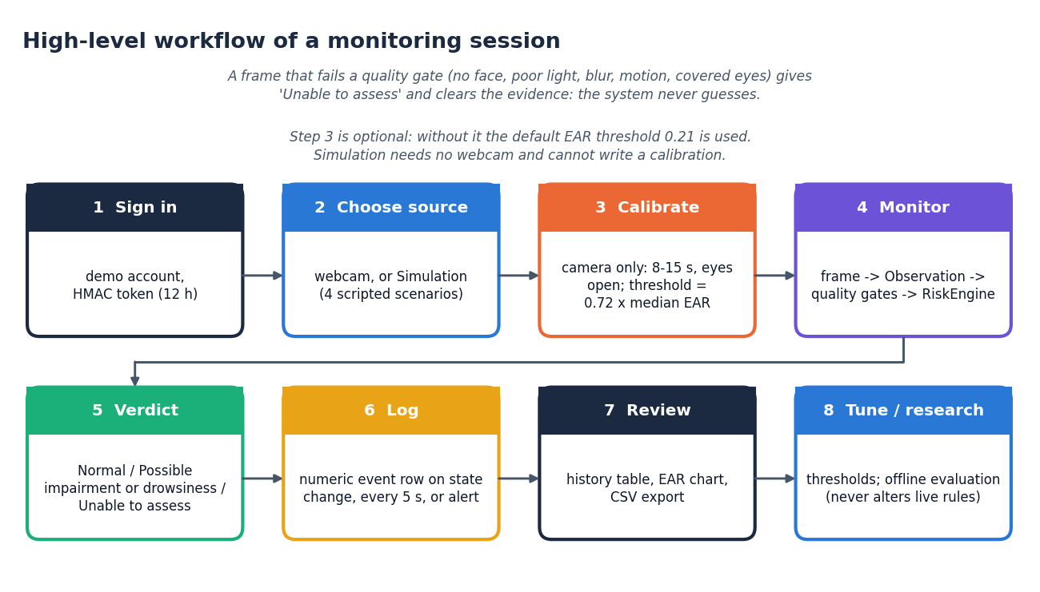
Figure 2: High-level workflow of a monitoring session
A session has eight steps. (1) Sign in with the demo account and receive a signed token valid for 12 hours. (2) Choose the source: the webcam, or Simulation with four scripted scenarios. (3) Calibrate, which applies to the camera only and is optional: with eyes open for 8 to 15 seconds the threshold is set to 0.72 times the median EAR; without it the default 0.21 is used, and simulation cannot write a calibration. (4) Monitor: each frame becomes an observation, passes the quality gates and is judged by the RiskEngine. (5) The verdict is one of Normal, Possible impairment or drowsiness, and Unable to assess. (6) A numeric event row is logged when the state changes, every five seconds, or when an alert fires. (7) The user reviews the history table, the EAR chart and the CSV export. (8) The user can tune the thresholds or run the offline evaluation, which never alters the live rules. The note on the diagram states the safety rule: a frame that fails a quality gate gives Unable to assess and clears the evidence, so the system never guesses.

Data flow diagram, level 0
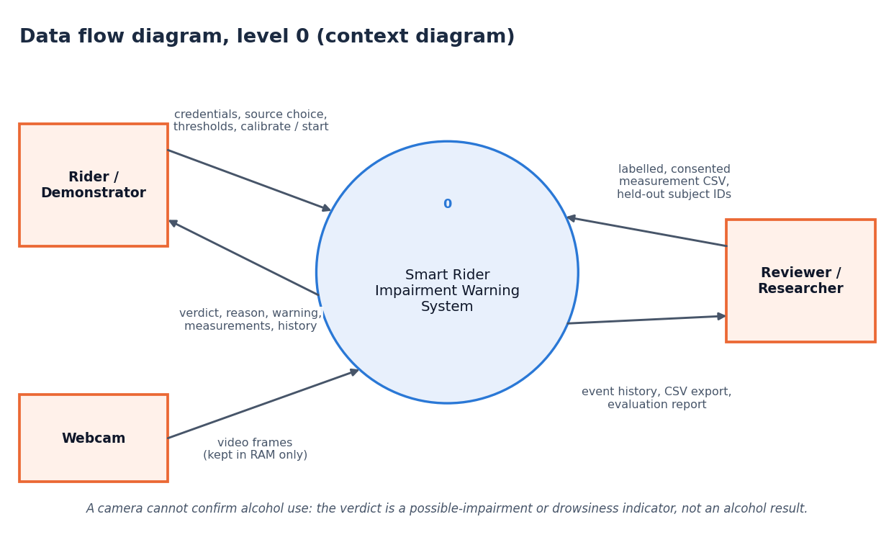
Figure 3: Data flow diagram, level 0 (context diagram)
The context diagram shows the system as one process with three external entities. The rider or demonstrator sends credentials, the source choice, thresholds and the calibrate, start and stop commands, and receives the verdict, the reason, the warning and the measurements, and the history. The webcam supplies video frames, which are kept in memory only. The reviewer or researcher supplies a labelled, consented measurement CSV and the held-out subject IDs and receives the event history, the CSV export and the evaluation report. The note on the diagram repeats the central limit: the verdict is a possible-impairment or drowsiness indicator, not an alcohol result.

Data flow diagram, level 1
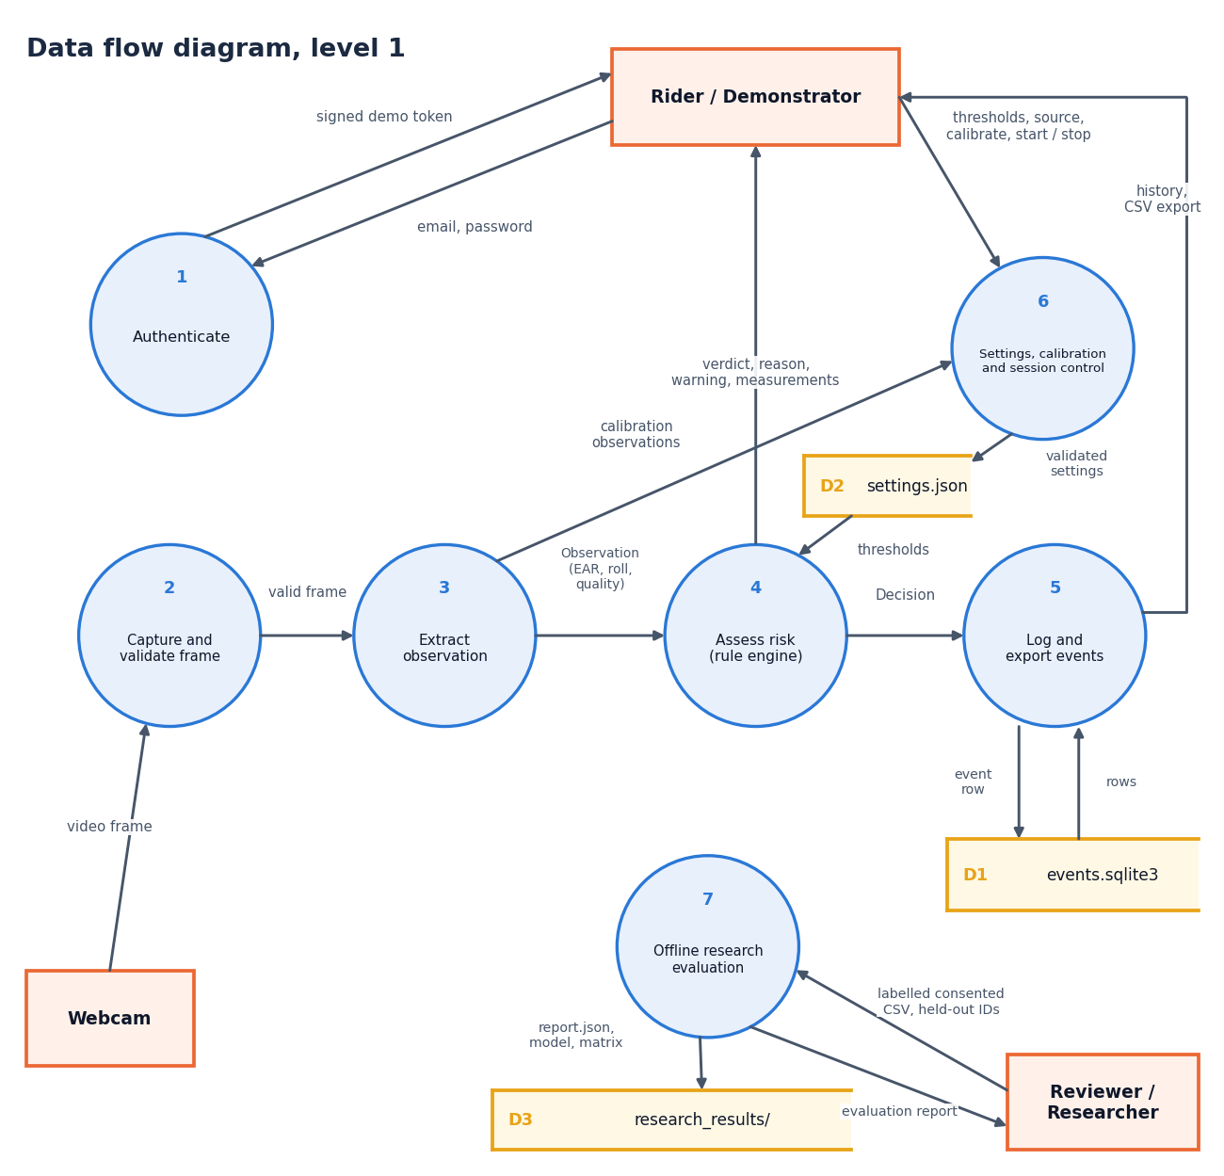
Figure 4: Data flow diagram, level 1
Level 1 has seven processes and three data stores. Authenticate (1) exchanges the email and password for a signed demo token. Capture and validate frame (2) takes the video frame from the webcam and passes on only a valid frame. Extract observation (3) turns it into an observation (time, EAR, roll, quality). Assess risk (4), the rule engine, turns observations and the thresholds read from the settings file (D2) into a decision, which goes to the rider and to Log and export events (5); process 5 writes event rows to the event database (D1), reads them back for the history and sends the history and the CSV export to the rider. Settings, calibration and session control (6) receives the rider's thresholds, source choice and calibrate, start and stop commands and the calibration observations, and writes validated settings to D2. Offline research evaluation (7) takes the reviewer's consented CSV and held-out IDs and writes the report, the model parameters and the confusion matrix to the research output folder (D3), returning the evaluation report to the reviewer.

Data flow diagram, level 2
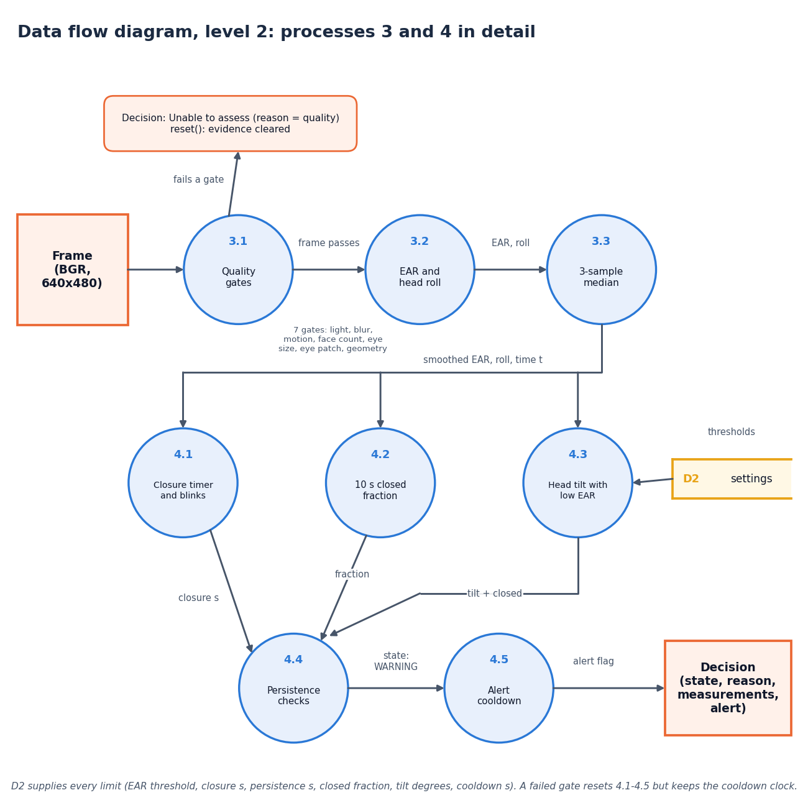
Figure 5: Data flow diagram, level 2: processes 3 and 4 in detail
Level 2 expands extraction and the rule engine. A frame (BGR, 640 x 480) first meets the quality gates (3.1): seven checks on light, blur, motion, face count, eye size, eye patch and eye geometry. A frame that fails any gate ends in Unable to assess with the reason equal to the quality label and the evidence cleared; a frame that passes goes to the EAR and head-roll computation (3.2) and then to the 3-sample median (3.3). The smoothed EAR, the roll and the time then feed three parallel rule checks: the closure timer and blink counter (4.1), the closed fraction over 10 seconds (4.2) and head tilt combined with a low EAR (4.3). Their outputs, closure seconds, the fraction and the tilt-and-closed flag, go to the persistence check (4.4), which decides the warning state, and then to the alert cooldown (4.5), which sets the alert flag. The output is the decision with state, reason, measurements and alert. The settings file D2 supplies every limit; a failed gate resets processes 4.1 to 4.5 but keeps the cooldown clock.

UML class diagram
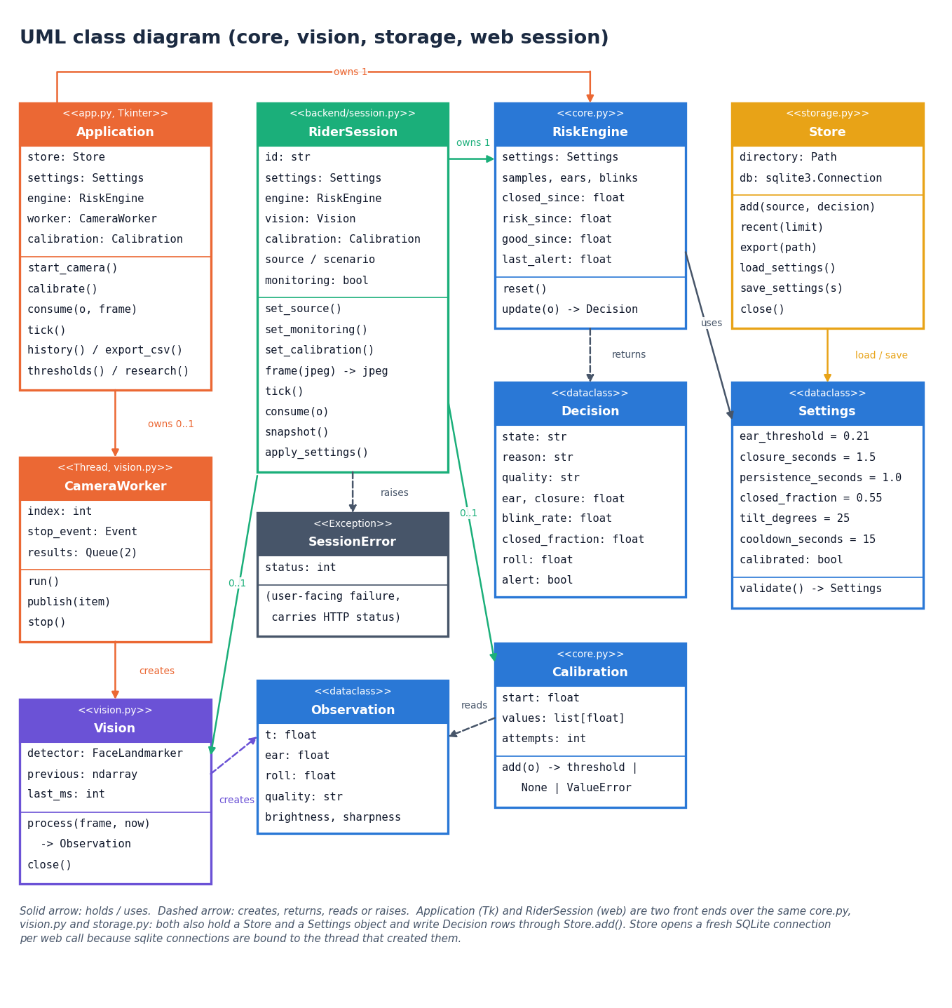
Figure 6: UML class diagram (core, vision, storage and web session)
The diagram draws the classes that carry the design. In core.py, Settings is a dataclass of the six thresholds and the calibrated flag with a validate method; Observation is one measurement (time, EAR, roll, quality, brightness, sharpness); Decision is the rule engine's answer (state, reason, quality, EAR, closure, blink rate, closed fraction, roll, alert). RiskEngine keeps the sample window, blinks and the closure and evidence timers, owns one Settings and returns a Decision from update; Calibration collects open-eye EAR values and returns a threshold or raises an error. Vision wraps the MediaPipe FaceLandmarker and creates Observation objects, and CameraWorker is the thread that runs it for the desktop app. Store writes events and settings. Application (Tkinter) and RiderSession (web) are two front ends over the same classes; each owns a Store, a RiskEngine and a Calibration, and RiderSession raises SessionError for user-facing failures. Store opens a fresh SQLite connection for each web call because connections are bound to their thread.

Sequence diagram
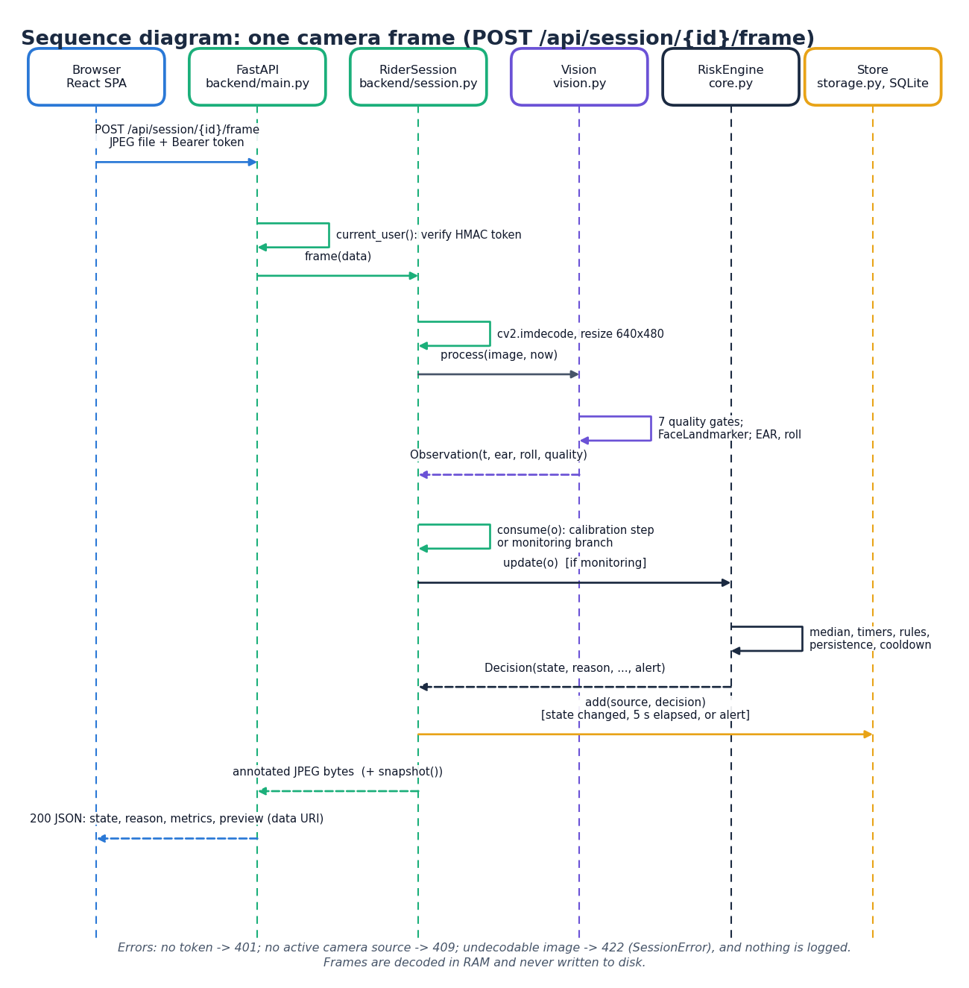
Figure 7: Sequence diagram: one camera frame (POST /api/session/{id}/frame)
The sequence follows one camera frame between six participants: the browser, the FastAPI service, the RiderSession, Vision, RiskEngine and Store. The browser posts the JPEG with the bearer token. FastAPI verifies the HMAC token in current_user and calls frame(data) on the session. The session decodes the bytes with cv2.imdecode and resizes the image to 640 x 480, then calls Vision.process(image, now), which applies the seven quality gates, runs the Face Landmarker and returns an Observation (time, EAR, roll, quality). consume(o) takes either the calibration step or the monitoring branch; while monitoring, RiskEngine.update(o) applies the median filter, timers, window, rules, persistence and cooldown and returns a Decision. If the state changed, five seconds have passed or an alert fired, Store.add writes the event row. The session returns the annotated JPEG bytes and the snapshot, and the API answers 200 with JSON containing the state, the reason, the metrics and the preview as a data URI. The note on the diagram lists the failure cases: a missing token gives 401, no active camera source gives 409, and an undecodable image gives 422 and logs nothing; frames are decoded in memory and never written to disk.

Use-case diagram
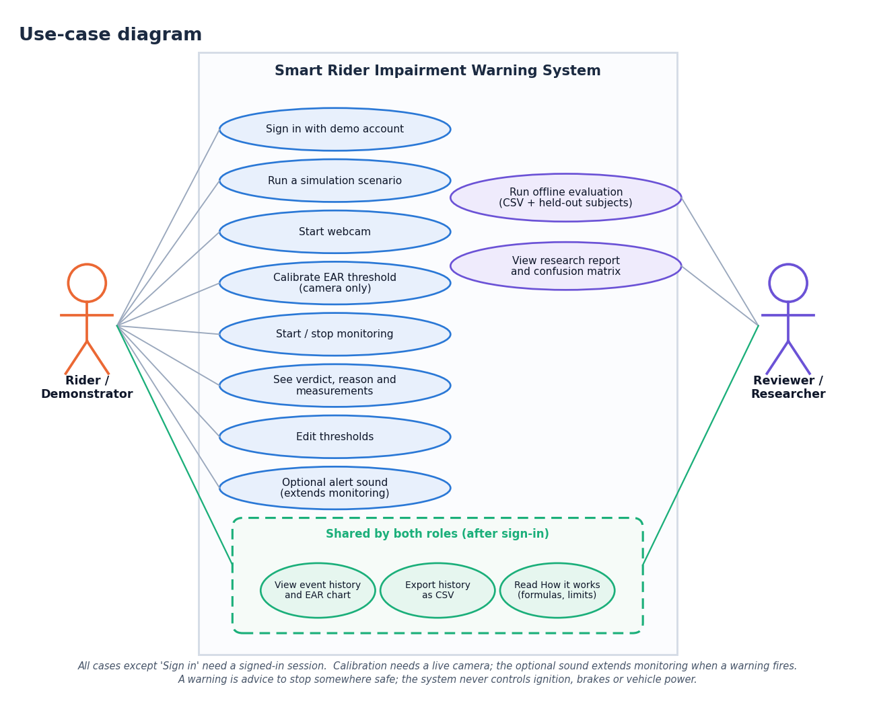
Figure 8: Use-case diagram
Two actors use the system. The rider or demonstrator can sign in with the demo account, run a simulation scenario, start the webcam, calibrate the EAR threshold (camera only), start and stop monitoring, see the verdict, reason and measurements, edit the thresholds and switch on the optional alert sound; dotted lines show that this actor may also open the history, the export and the explanation page. The reviewer or researcher can view the event history and the EAR chart, export the history as CSV, read the How it works page (formulas and limits), run the offline evaluation with a CSV and held-out subjects, and view the research report and confusion matrix. Calibration needs a live camera, and the optional sound extends monitoring when a warning fires. A warning is advice to stop somewhere safe: the design contains no use case that controls ignition, brakes or vehicle power, contacts another person or reports alcohol consumption.

Entity-relationship diagram
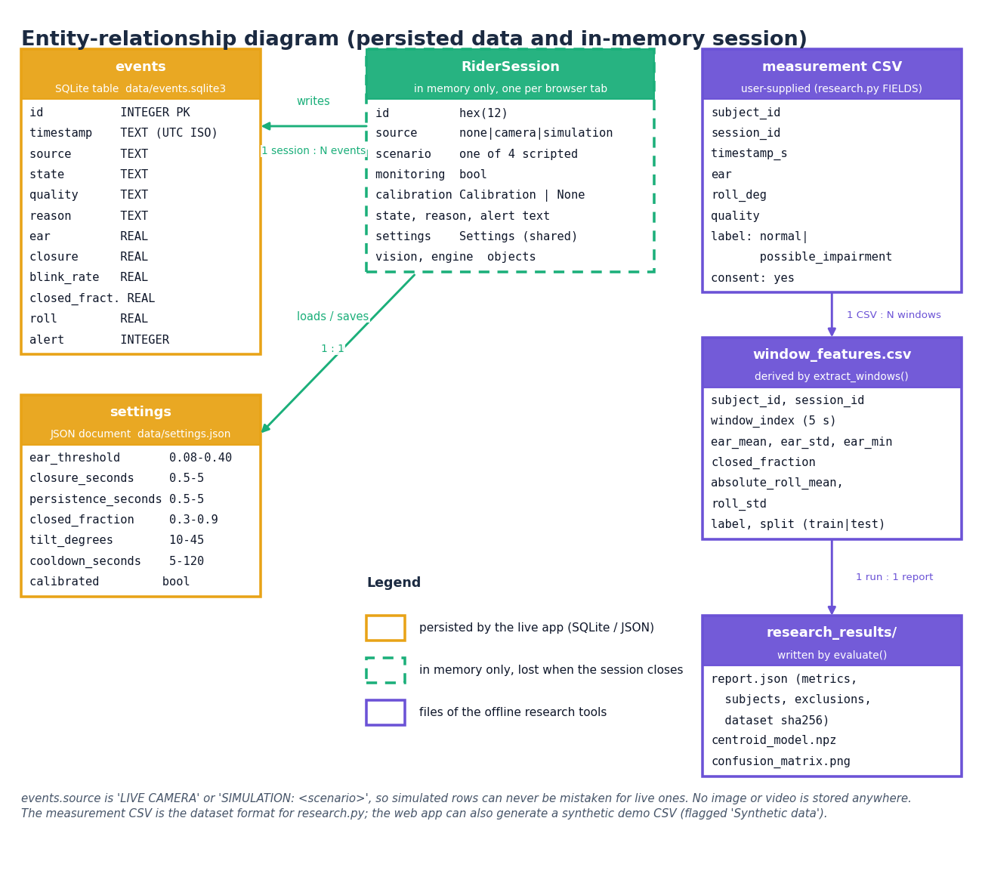
Figure 9: Entity-relationship diagram (persisted data and in-memory session)
The diagram separates three kinds of data by colour. Persisted by the live application: the SQLite table events with twelve columns (id, timestamp, source, state, quality, reason, ear, closure, blink_rate, closed_fraction, roll, alert), and the JSON document settings with the six thresholds, their allowed ranges and the calibrated flag. In memory only: RiderSession, one per browser tab, with its id, source, scenario, monitoring flag, calibration object, state, reason, alert, settings and the vision and engine objects; one session writes zero or many events and loads and saves the one settings document, and it is lost when the session closes. Files used or produced by the offline research tools only: the user-supplied measurement CSV (eight columns), the derived window_features.csv (one CSV gives many 5-second windows, each with its features, label and train or test split) and the research_results/ folder (report.json, centroid_model.npz and confusion_matrix.png; one run gives one report, overwritten by the next). The source column is either LIVE CAMERA or SIMULATION with the scenario name, so simulated rows can never be mistaken for real ones, and no image or video is stored anywhere.

Flowchart of the core algorithm
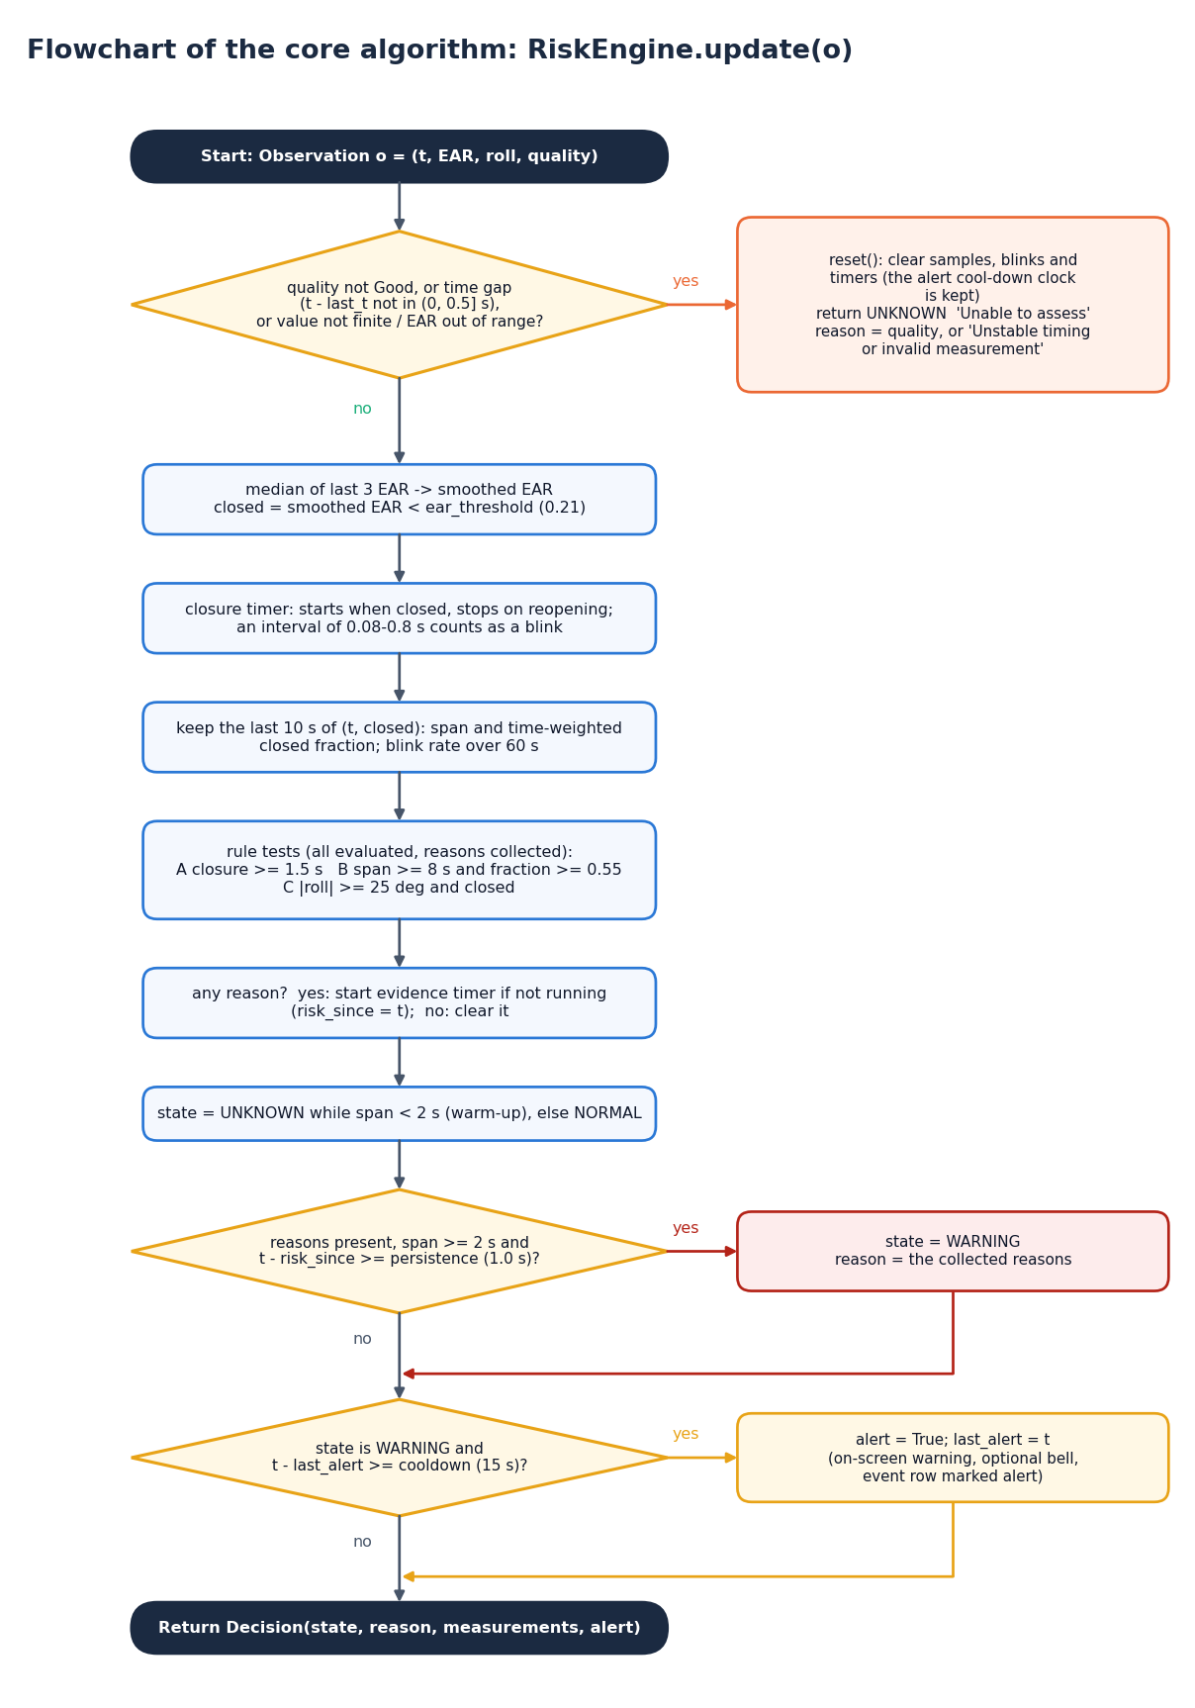
Figure 10: Flowchart of the core algorithm (RiskEngine.update)
The flowchart follows RiskEngine.update for one observation. First, if the quality is not Good, the time gap is outside (0, 0.5] seconds, or a value is not finite or the EAR is out of range, the engine clears its samples, blinks and timers (keeping the alert cooldown clock) and returns Unable to assess with the quality label or the reason 'Unstable timing or invalid measurement'. Otherwise the last three EAR values are median-filtered and compared with the threshold; the closure timer runs while the eye is closed, and a closure of 0.08 to 0.8 s is counted as a blink. The last 10 seconds of samples give the span and the time-weighted closed fraction, and the blink rate is computed over 60 seconds. Three rule tests are then evaluated and their reasons collected: A, closure of 1.5 s or more; B, a span of at least 8 s and a fraction of at least 0.55; C, absolute roll of at least 25 degrees while the eye is closed. If any reason exists the evidence timer starts (if not already running), otherwise it is cleared. The state is Unable to assess while the span is under 2 s (warm-up) and Normal otherwise. If reasons are present, the span is at least 2 s and the evidence has lasted the persistence time (1.0 s), the state becomes Possible impairment or drowsiness with the collected reasons. Finally, if the state is the warning and the cooldown (15 s) has passed since the last alert, the alert flag is set (the on-screen warning, the optional bell and the marked event row), and the decision is returned.

